**Resume:**

In this analysis, I will present to you a brief summary of the importance of Big Data Modeling and Artificial Intelligence. As we already know, the internet and the era of information have changed how we collect information, but now we live in a new era: the era of Artificial Intelligence.

We are experiencing a significant shift, as society embraces advanced technology like never before. With Artificial Intelligence, there is a mix of fascination and apprehension. On one hand, it's incredible what AI can do, but on the other hand, it also raises concerns and fears. However, one thing is clear: AI has the potential to revolutionize how we operate. It's streamlines tasks that used to be complex, now simplifying them with just a few clicks.

In the following analysis, will investigate this phenomenon and explore its implications. In the summary you will find: Analyzing social media with AI to predict health conditions holds immense potential, passing through collaboration between humans and artificial intelligence in the creation of creative products, to then understand how the business intelligence system provides important and competitive information to business planners and decision-makers by combining operational and historical data with analytical tools, and it concludes with data mining methods based on research objectives and available data.

We know the potential of using Artificial Intelligence (AI) and in this case, will analyze social media data for predicting mental health conditions, highlights its effectiveness in identifying depression and other disorders. On the paper of Thomas Ploug *“The night not to be Subject to AI profiling based on publicity Available data. Privacy and exceptionalism of AI profiling”*, it examines the debate surrounding AI regulation due to its predictive capabilities and privacy concerns, proposing the establishment of a legal right to refuse AI profiling based on public data without explicit consent. The discussion involves arguments supporting this right, such as protection against social control, stigma, and harm to individual autonomy and well-being. Despite the General Data Protection Regulation (GDPR), the article suggests that it could indirectly guarantee it through certain prohibitions. It evaluates different scenarios under the GDPR, emphasizing the need for an explicit right to protect individuals from potential harm. And finally, the article advocates for informed consent and stricter regulation to safeguard individuals against AI profiling and its associated risks.

Then let me introduces a framework for designing and evaluating human-AI co-creation systems, delving into the challenges and opportunities of collaboration in creative product creation. A text from Jeba Rezwana and Mary Lou Maher titled: *“Designing creative AI partners with COFI: A framework for modeling interaction in human-AI CoCreative System”* emphasizes the importance of interaction design in such systems. It outlines various collaboration and communication styles between human collaborators and AI agents. The Co-Creative Framework for Interaction Design (COFI), presented as a guide, defining interaction components like participation style, task distribution, initiative timing, and mimicry. COFI aims to inform the design of interaction models and assess existing ones. The discussion includes: prior research on human creative collaboration, interaction design in co-creation systems, and an analysis of interaction models in 92 such systems to evaluate COFI. The text, identifies gaps in current models and suggests directions for future development, emphasizing the need to improve communications styles, as well as model clusters tailored to different AI agent types. Overall, COFI offers a comprehensive framework for understanding and designing interactions in co-creation systems, considering the diverse dynamics between humans’ collaborators and AI.

Business Intelligence (BI) Systems in the article of Jasmin Praful Bharadiya entitled *“A comparative study of business intelligence and artificial intelligence with big data analytics”* describes how BI systems provide competitive insights through the analysis of operational and historical data. These systems employ various technological techniques, including data mining, to extract valuable information from datasets. Machine learning technologies, such as deep learning, are utilized to develop decision-making models from raw data. Additionally, BI encompasses data mining methods like text analysis, web exploration, and big data analytics. It constitutes a broad spectrum of computer solutions aimed at acquiring, analyzing, and reporting data on an organization's performance and its surrounding environment. The text also touches upon machine learning and deep learning methodologies, along with the hardware and software resources utilized within this domain.

And last but not least, the data mining for large volumes of data, focusing on extracting valuable information from vast datasets, also known as Big Data. It discusses the challenges posed by the sheer volume, diversity, and rapid generation of these datasets, highlighting the need for techniques like data mining to derive insights. The literature review section covers various data mining methods tailored for big data, including classification, clustering, and sentiment analysis, with case studies demonstrating their effectiveness across domains like healthcare, finance, and marketing. The text also discusses a research methodology that utilizes data from the PISA 2022 study to evaluate student performance, emphasizing the importance of adapting data mining approaches to suit research objectives and available data characteristics. Overall, it underscores the crucial role of data mining in extracting meaningful insights from massive and complex datasets for diverse applications.

The four articles focus on data analysis and the application of technologies such as artificial intelligence and data mining in various contexts. Here's a summary and a simple diagram to illustrate their connections:

1. Article 1: Artificial Intelligence in Predicting Health Conditions:

* Discusses the use of artificial intelligence to analyze social networks and predict mental health conditions.
* Focuses on social network data analysis and the application of AI techniques for health condition prediction.

1. Article 2: Framework for Human-AI Co-Creation:

* Introduces a framework for designing and evaluating human-AI co-creation systems, highlighting the importance of interaction design.
* Addresses the design of systems involving collaboration between humans and AI, which includes data analysis and effective communication.

1. Article 3: Business Intelligence (BI) Systems:

* Describes how BI systems provide competitive insights through the analysis of operational and historical data.
* Explores data analysis and the use of analytical tools in the business context, emphasizing the importance of data mining.

1. Article 4: Data Mining for Large Volumes of Data:

* Examines the use of data mining techniques to extract valuable information from large datasets, known as 'big data'.
* Focuses on the application of data mining in managing and analyzing large datasets, with an emphasis on its use in various fields such as education and research.

The simple diagram below illustrates the connections between these articles:

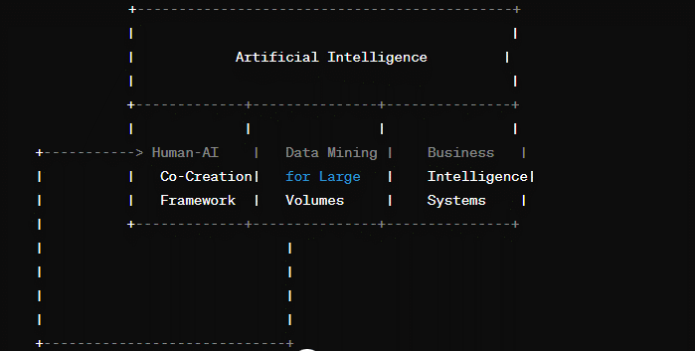

This diagram shows how the themes of artificial intelligence, human-AI co-creation, data mining, and business intelligence systems are interconnected in the four articles. Each area overlaps and contributes to the understanding and application of technologies and data analysis in various fields.